Semester One Examination, 2024

Question/Answer booklet

MATHEMATICS  
SPECIALIST  
UNIT 3 Year 12

If required by your examination administrator, please place your student identification label in this box

Section Two:  
Calculator-assumed

|  |  |  |  |  |  |  |  |  |  |  |
| --- | --- | --- | --- | --- | --- | --- | --- | --- | --- | --- |
| WA student number: In figures |  |  |  |  |  |  |  |  |  |  |

In words

Your name

|  |  |
| --- | --- |
| Number of additional answer booklets used (if applicable): |  |

## Time allowed for this section

Reading time before commencing work: ten minutes

Working time: one hundred minutes

## Materials required/recommended for this section

***To be provided by the supervisor***

This Question/Answer booklet

Formula sheet (retained from Section One)

***To be provided by the candidate***

Standard items: pens (blue/black preferred), pencils (including coloured), sharpener,  
correction fluid/tape, eraser, ruler, highlighters

Special items: drawing instruments, templates, notes on two unfolded sheets of A4 paper, and up to three calculators, which can include scientific, graphic and Computer Algebra System (CAS) calculators, are permitted in this ATAR course examination

## Important note to candidates

No other items may be taken into the examination room. It is **your** responsibility to ensure that you do not have any unauthorised material. If you have any unauthorised material with you, hand it to the supervisor **before** reading any further.

## Structure of this paper

|  |  |  |  |  |  |
| --- | --- | --- | --- | --- | --- |
| Section | Number of questions available | Number of questions to be answered | Working time (minutes) | Marks available | Percentage of examination |
| Section One: Calculator-free | 8 | 8 | 50 | 97 | 35 |
| Section Two: Calculator-assumed | 13 | 13 | 100 | 160 | 65 |
|  | | |  | **Total** | 100 |

|  |  |  |
| --- | --- | --- |
| Markers use only | | |
| Question | Maximum | Mark |
| 9 | 5 |  |
| 10 | 15 |  |
| 11 | 8 |  |
| 12 | 16 |  |
| 13 | 9 |  |
| 14 | 10 |  |
| 15 | 13 |  |
| 16 | 9 |  |
| 17 | 12 |  |
| 18 | 27 |  |
| 19 | 10 |  |
| 20 | 14 |  |
| 21 | 13 |  |
| S2 Total | 161 |  |
| S2 Wt (×0.7222) | 65% |  |

## Instructions to candidates

1. The rules for the conduct of examinations are detailed in the school handbook. Sitting this examination implies that you agree to abide by these rules.

2. Write your answers in this Question/Answer booklet preferably using a blue/black pen.  
Do not use erasable or gel pens.

3. You must be careful to confine your answers to the specific question asked and to follow any instructions that are specific to a particular question.

4. Show all your working clearly. Your working should be in sufficient detail to allow your answers to be checked readily and for marks to be awarded for reasoning. Incorrect answers given without supporting reasoning cannot be allocated any marks. For any question or part question worth more than two marks, valid working or justification is required to receive full marks. If you repeat any question, ensure that you cancel the answer you do not wish to have marked.

5. It is recommended that you do not use pencil, except in diagrams.

6. Supplementary pages for planning/continuing your answers to questions are provided at the end of this Question/Answer booklet. If you use these pages to continue an answer, indicate at the original answer where the answer is continued, i.e. give the page number.

7. The Formula sheet is not to be handed in with your Question/Answer booklet.

Section Two: Calculator-assumed 65% (105 Marks)

This section has**eleven** questions. Answer **all** questions. Write your answers in the spaces provided.

Working time: 100 minutes.

Question 9 (5 marks)

The complex number function is given below.

The sketch of the graph is shown on an Argand diagram. By proving that the Cartesian equation of is give, find the minimum value of and maximum value of .

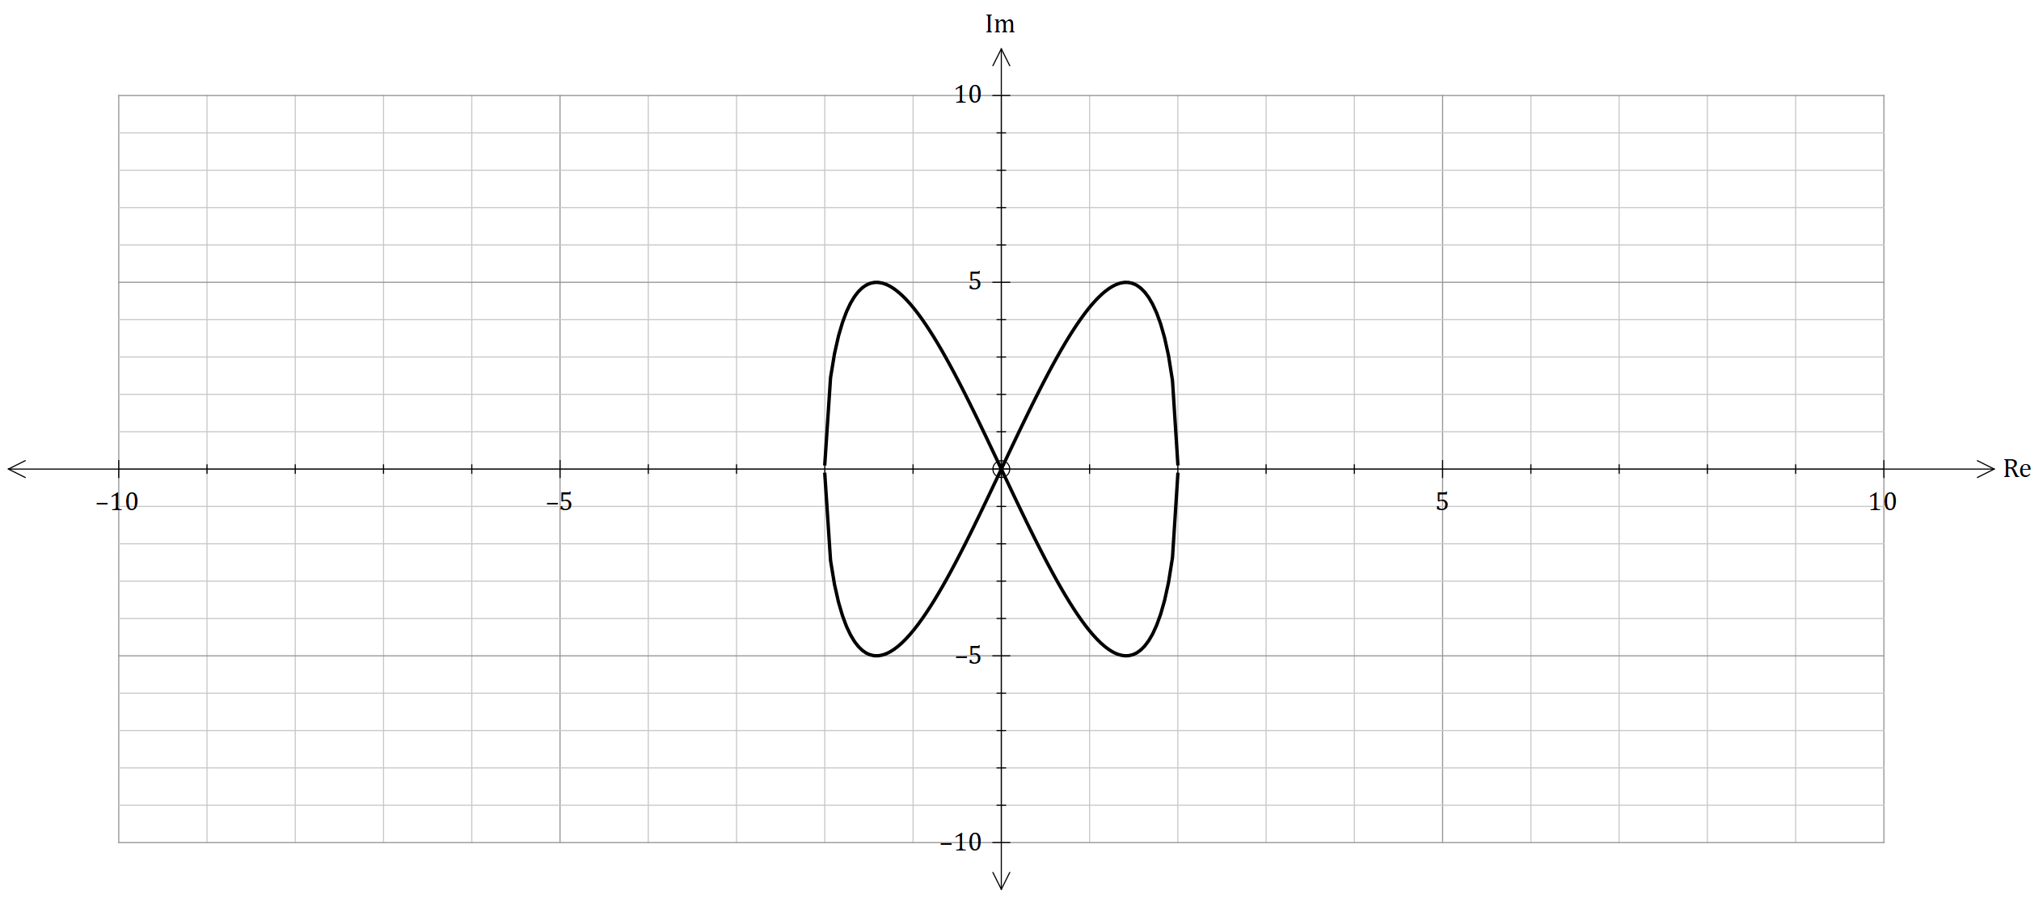

**Question 10 (15 marks)**

The complex number is given by , where .

1. By considering the binomial expansion of , show that. (6 marks)

The vector function is shown below as

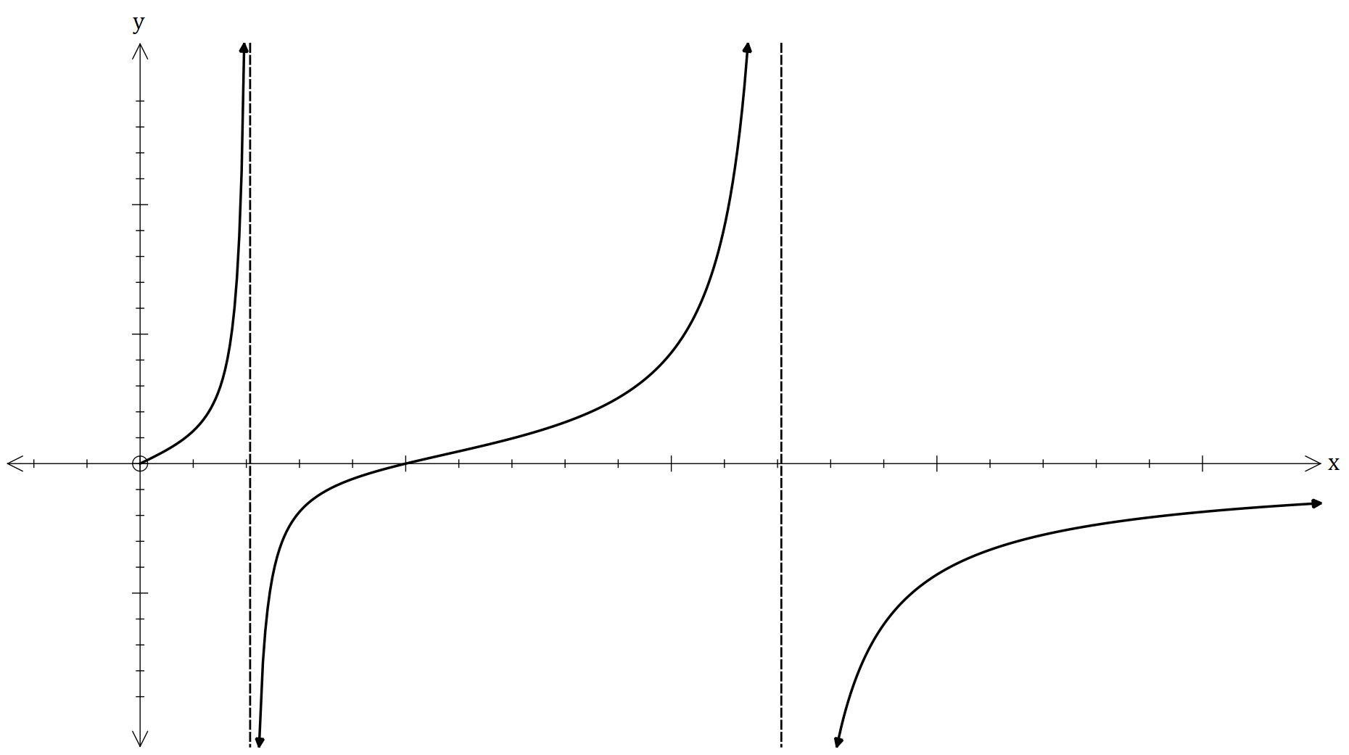

for seconds.

It is further graphed to the right.

1. Hence find, plot the roots of and   
   their values of the vector function

on the graph. (3 marks)

The domain for can be restricted in several ways, so that can exist. These choices are listed

below in terms of the constants and .

1. By finding the values of the and , write the restrictions in terms of . (4 marks)

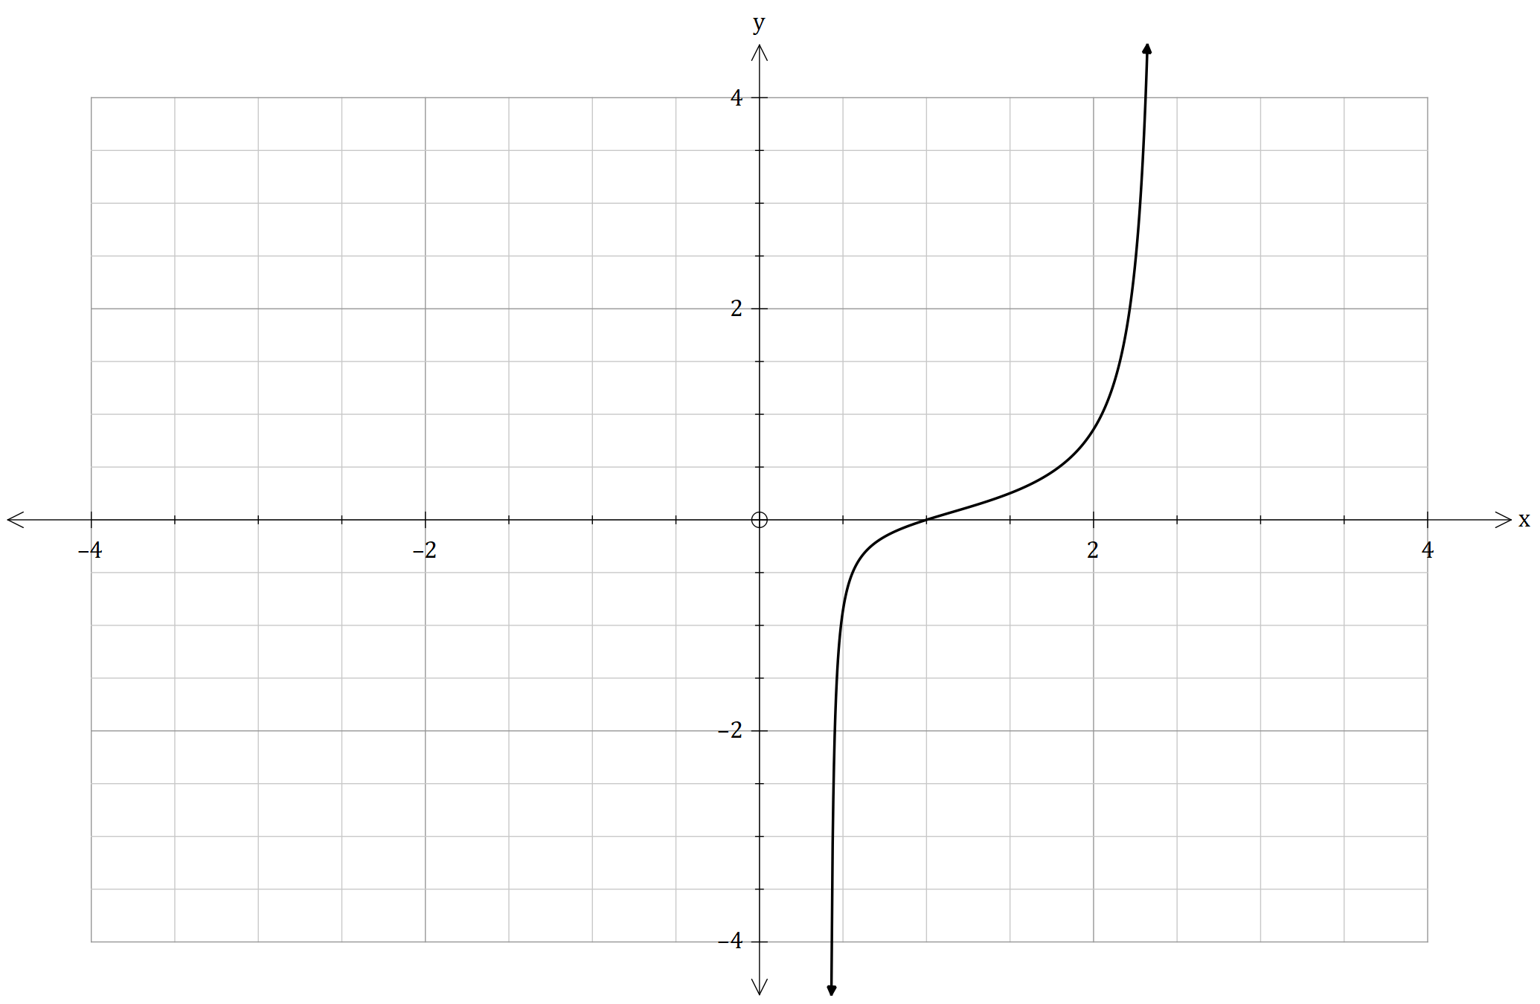The vector function is restricted with the domain as shown below.

1. Plot the inverse vector function on the graph above. (2 marks)

**Question 11 (9 marks)**

1. Two parallel planes are labelled as and . The points and , belong on the planes. Prove that the shortest distance , between the two planes is the expression below. (3 marks)

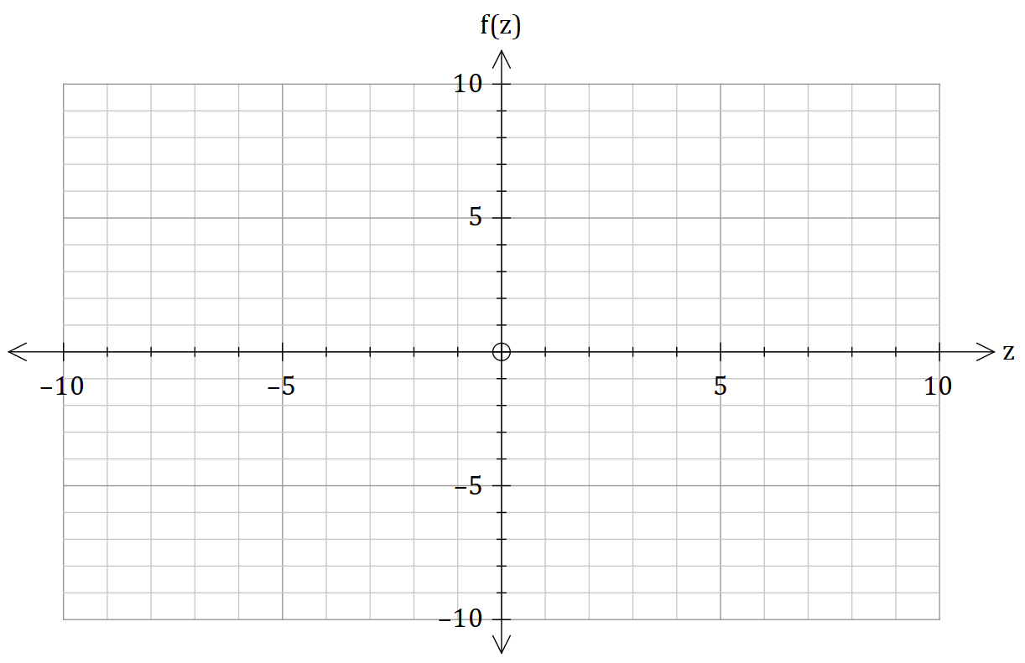

1. The curve given below. By  
   using the coordinates of all intercepts,   
   equations of all asymptotes, coordinates   
   of all stationary points and their nature.  
   Sketch the curve ,   
   indicating all the important  
   features, with correct to decimal places  
   if needed. (6 marks)

**Question 12 (16 marks)**

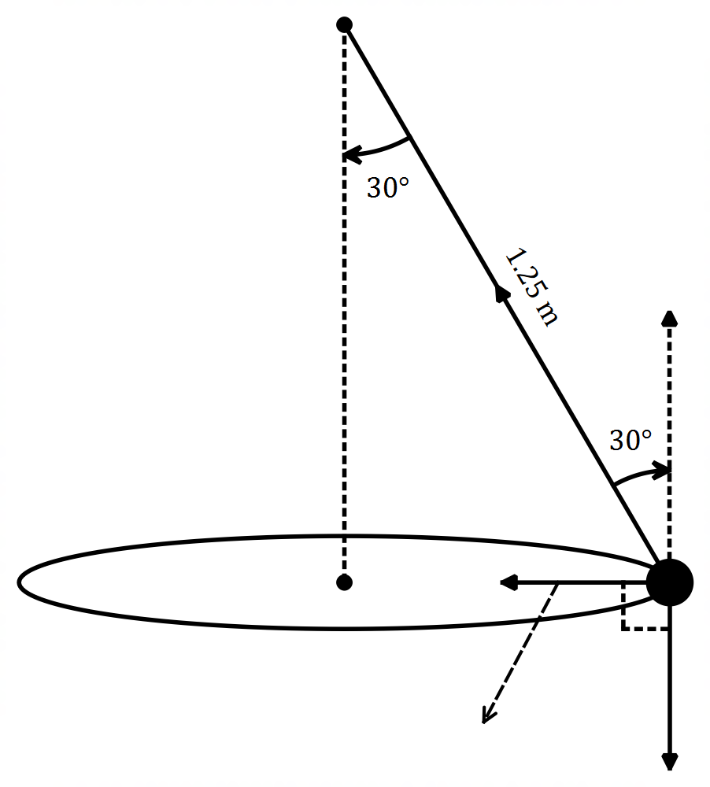

The figure to the right shows a tennis ball of mass.

of kg, in horizontal circular motion, where it’s

attached to one end of a light string with a length.

of metres. The forces acting on the ball is the

tension , the apparent normal force , the

gravitational force where ms-2

and is the mass in kg. The total summation of

forces is the centripetal force with ms-2

for seconds. The point is labelled as the origin.

The ball has a period of seconds with a

constant speed of ms-1.

1. If the ball had a period for seconds, with  
   a constant speed of ms-1, determine

if was in the form given below. (6 marks)

It’s recorded that for every seconds, a complete rotation is done and travels with a distance of metres for every rotation.

1. Find the value of the constant and . (4 marks)
2. Find the apparent normal force , by using vector methods . (3 marks)
3. Evaluate if is always perpendicular to the force for one rotation. (3 marks)

**Question 13 (9 marks)**

A specialist student throws a stone of mass kg from the top of a hill. The launch position at the top of the cliff is m above ground level. The stone lands metres in front of the launch position. The initial launch speed is ms-1 and is at an angle of to the horizontal. The only force acting on the stone, is the force due to gravity , where the acceleration of the force due to gravity is ms-2. The scenario is shown in the diagram below.

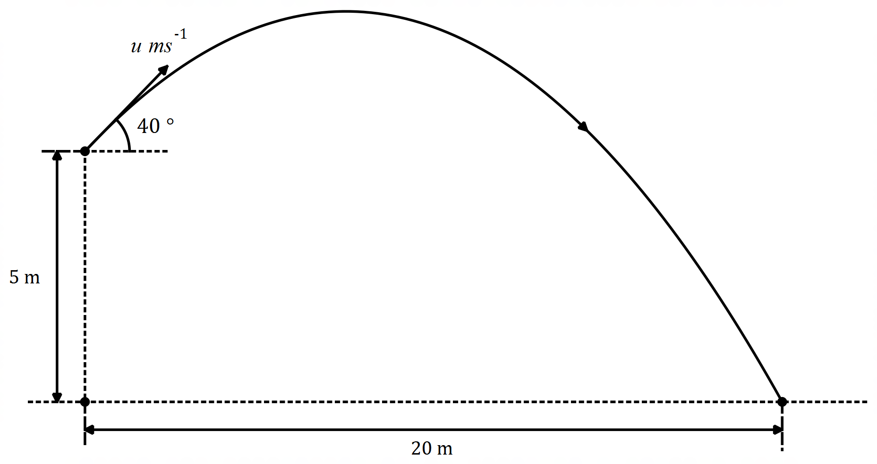

1. If the flight path took seconds, find the initial launch speed of the stone. (6 marks)
2. Calculate the final **vertical** speed of the stone. (3 marks)

**Question 14 (10 marks)**

1. The acceleration of a particle at time seconds is given by cms-2. It’s initial displacement and velocity are cm and cms-1 respectively. Find the velocity and angle of when it crosses with the x-y plane. (3 marks)
2. 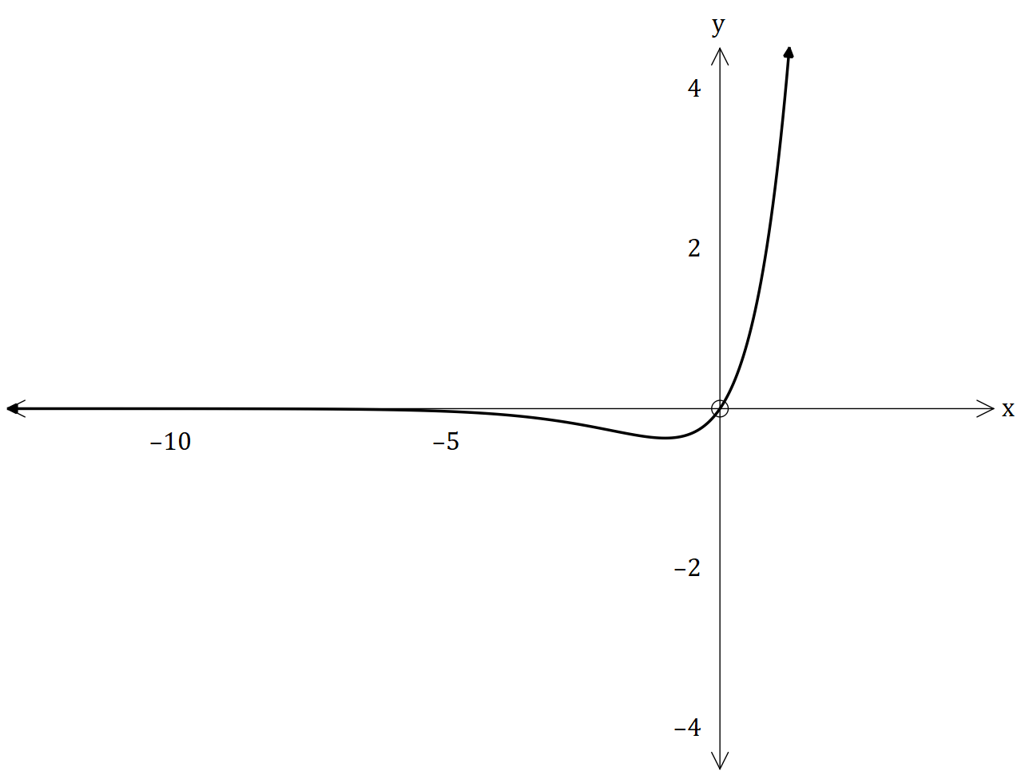The vector function is shown below.

Prove with justification that has only   
one local minimum point. State the   
coordinates of this point. (3 marks)

1. The moving bodies and with their given position vectors at time are given as  
    and . State whether the bodies collide. (4 marks)

**Question 15 (13 marks)**

The function is graphed below.

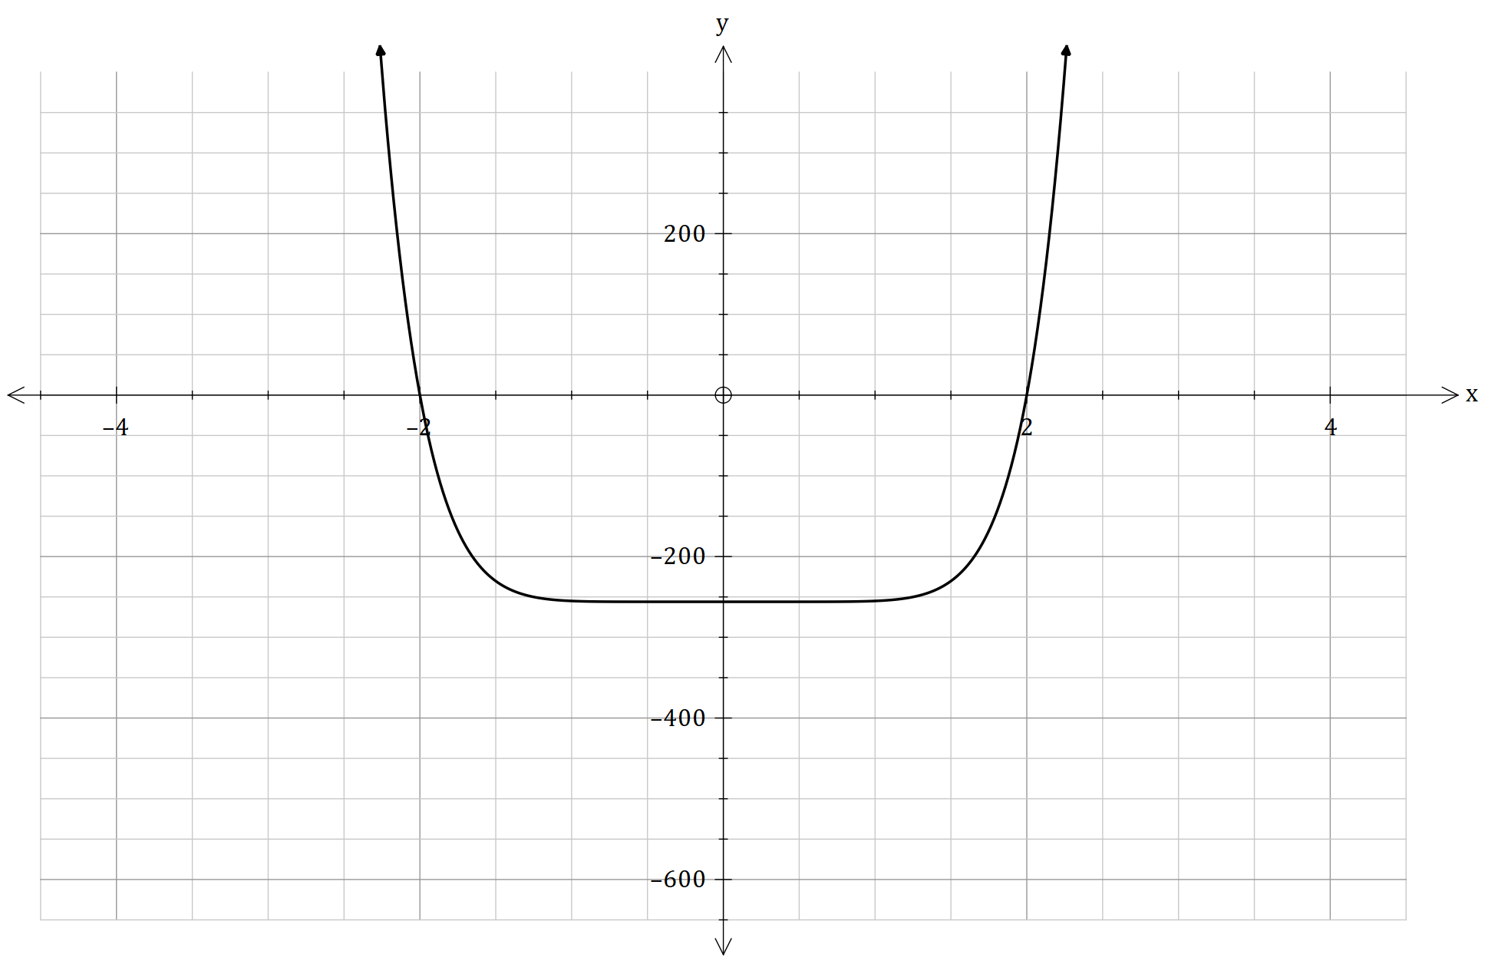

can be factorised with multiple quadratic factors, as shown below.

1. Justify using the graph of , if is exactly divisible for . (2 marks)
2. If able to, plot all the roots in the Argand polar diagram below. (3 marks)

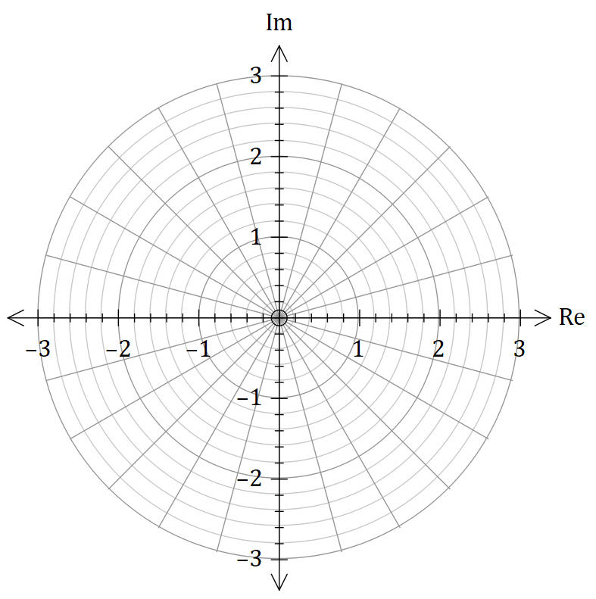

The function and another function in the form of , formed an optical

illusion, by creating an ‘infinity flower’, as shown below. The roots of the function formed the

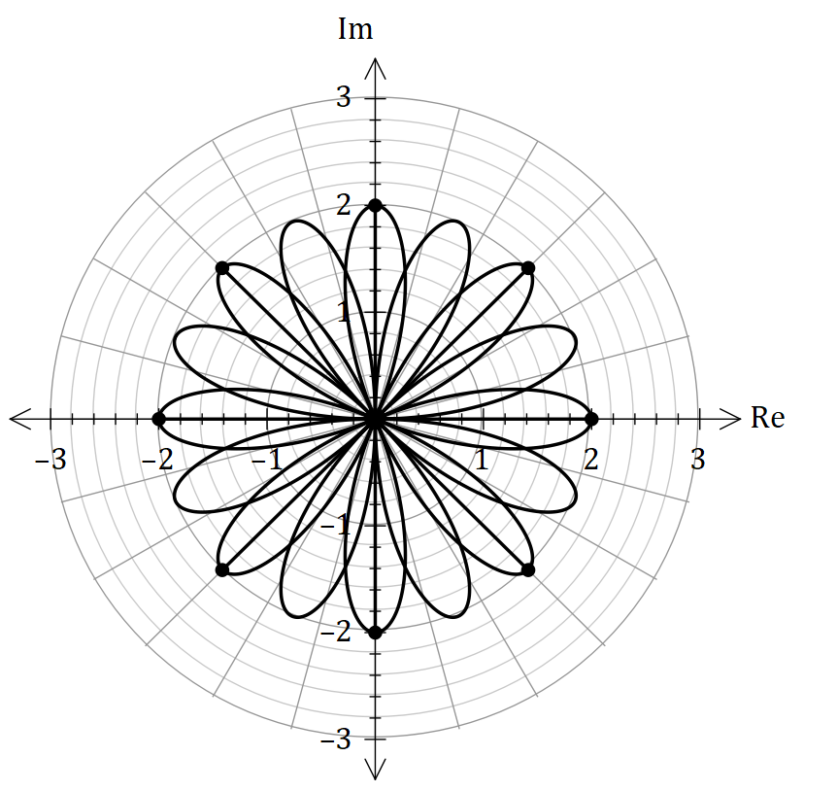equation and the roots of formed the equation .

One of the points that crosses are

The polar coordinates and .

1. Hence, find (4 marks)
2. Hence if another function is within the form of a rational function as such below, where is the quotient and is the remainder. Prove that the following sketch of below, corresponds to the form shown. (4 marks)

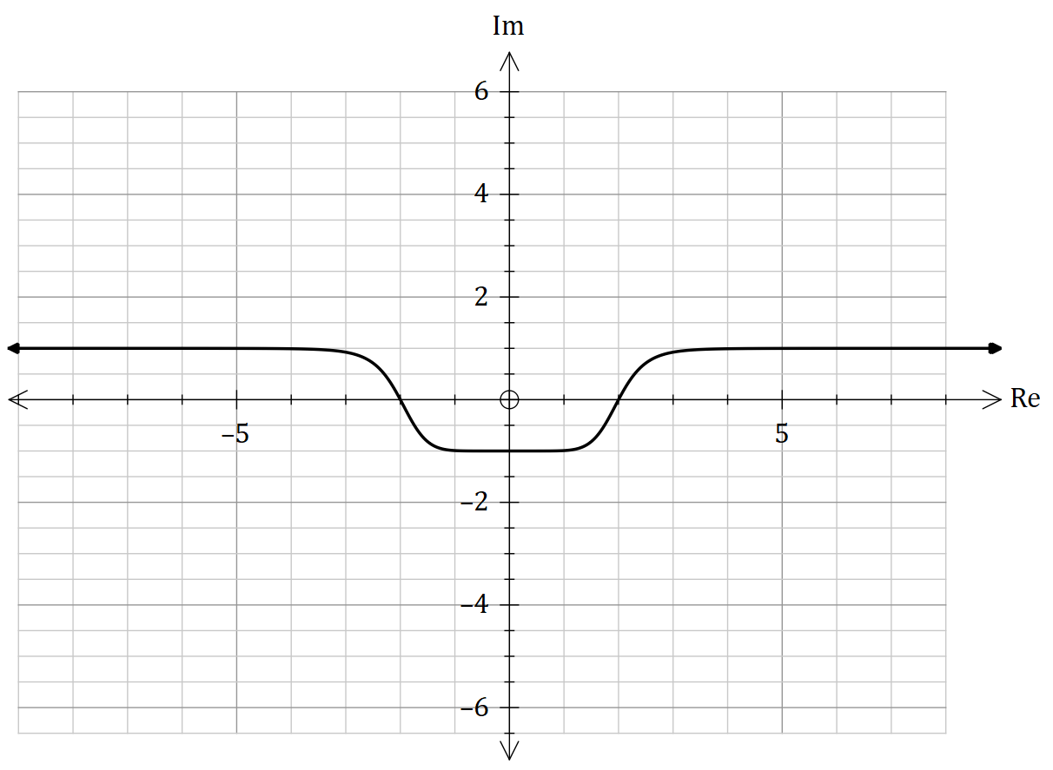

**Question 16 (9 marks)**

The complex number function is given as .

One of the solutions for are graphed below in the complex polar grid.

Given that and if , find all the solutions of . (For complex

solutions, make them be in the form of )

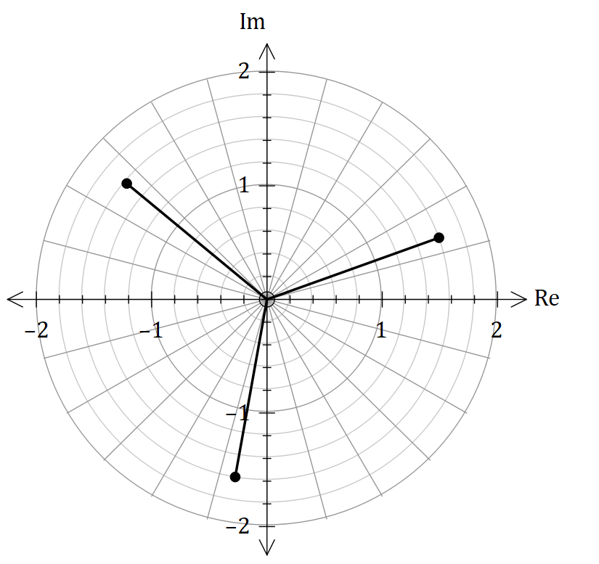

**Question 17 (12 marks)**

The graph shown below is a function named Lori’s Function. The equation for Lori's Function is.

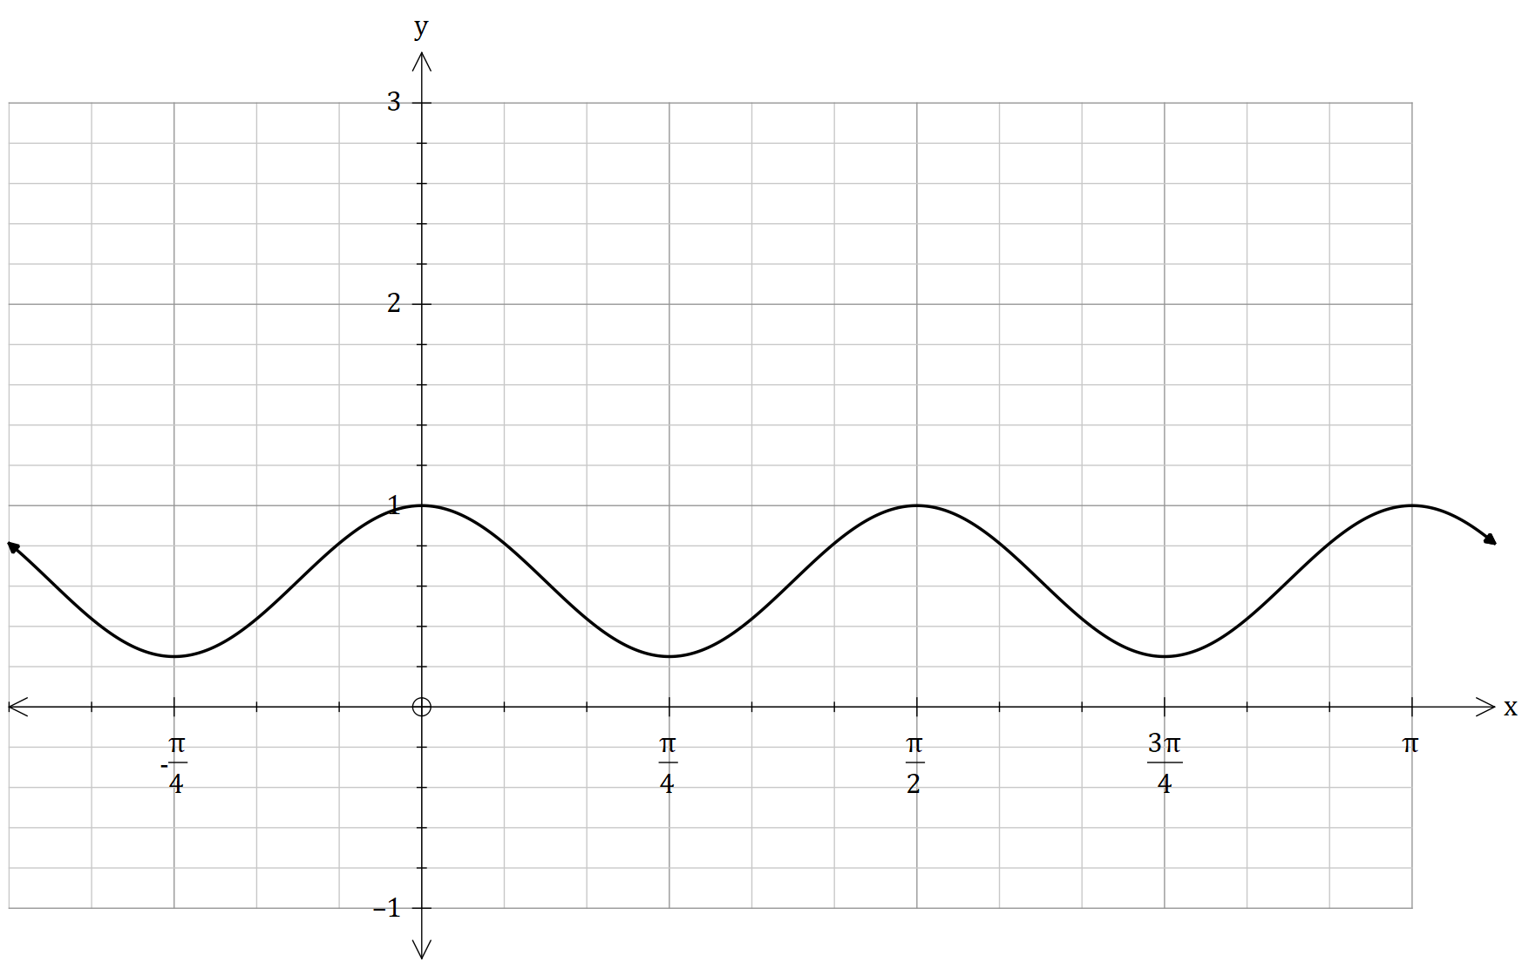

Consider the complex number

1. By using that , show the given expression. (2 marks)
2. Hence, show further by using your answer at a) (4 marks)
3. Use the fact that , to find a similar expression for . (3 marks)
4. Hence, by finding the exact value of the integral, find the area between the -axis for the interval . (3 marks)

**Question 18 (27 marks)**

A subatomic particle labelled as , has a path of a three-dimensional curve. The particle,

begins at a point and is shown to the right.

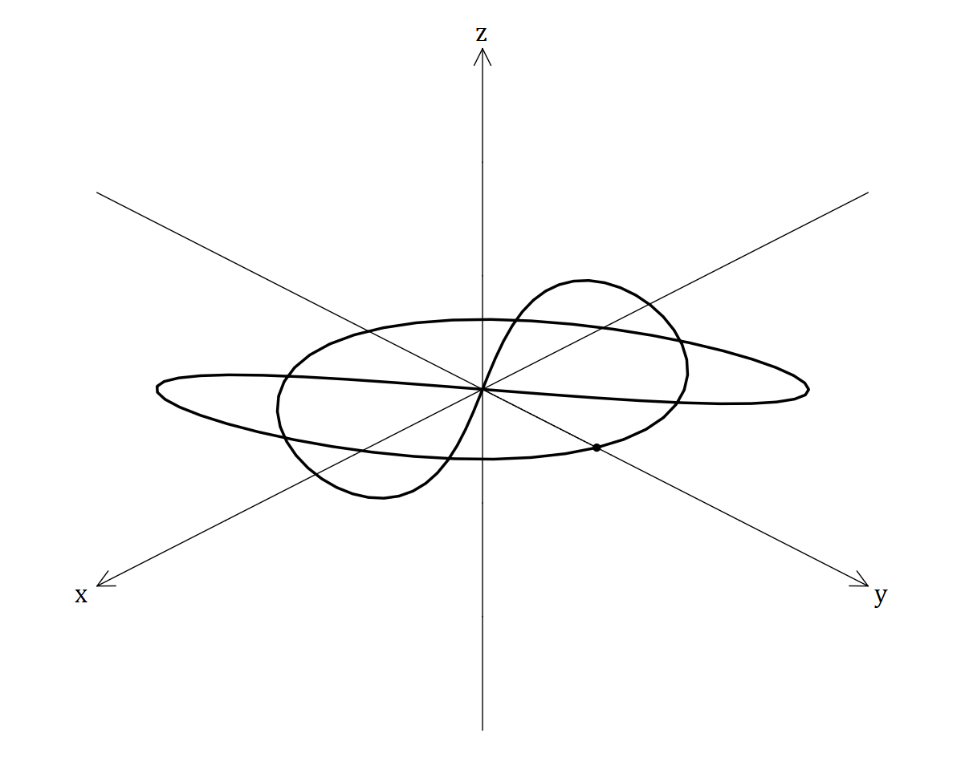

It’s position vector for seconds is

specified/given below.

metres

Where belongs to the interval

seconds.

1. Determine the length of the path

taken by , correct to metres.  
(3 marks)

1. Determine the initial acceleration vector and indicate this clearly on the diagram above.

(3 marks)

1. By considering and De Moive’res theorem, prove that the vector function can be expressed as. (5 marks)

ms-1

1. At what times does the path of cross the x-y plane. (2 marks)
2. By considering the and components for , what is the angle that the path of makes with the x-y plane. (2 marks)
3. Using your answer in e), find the shortest distance between and the plane with the vector equation . (6 marks)

Another subatomic particle has the vector equation ms-1 for seconds given below.

The particle passes through the point . It is believed that the path of and collide at a certain point at two different times.

1. Hence, evaluate whether and will collide. If they collide, plot the point at the diagram below for , and determine the vector line , that is tangential to the collision coordinate. If they don’t collide, justify your answer. (5 marks)

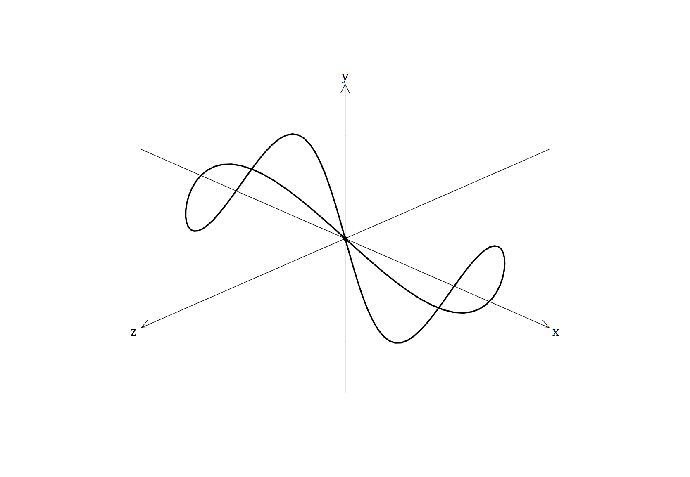

**Question 19 (10 marks)**

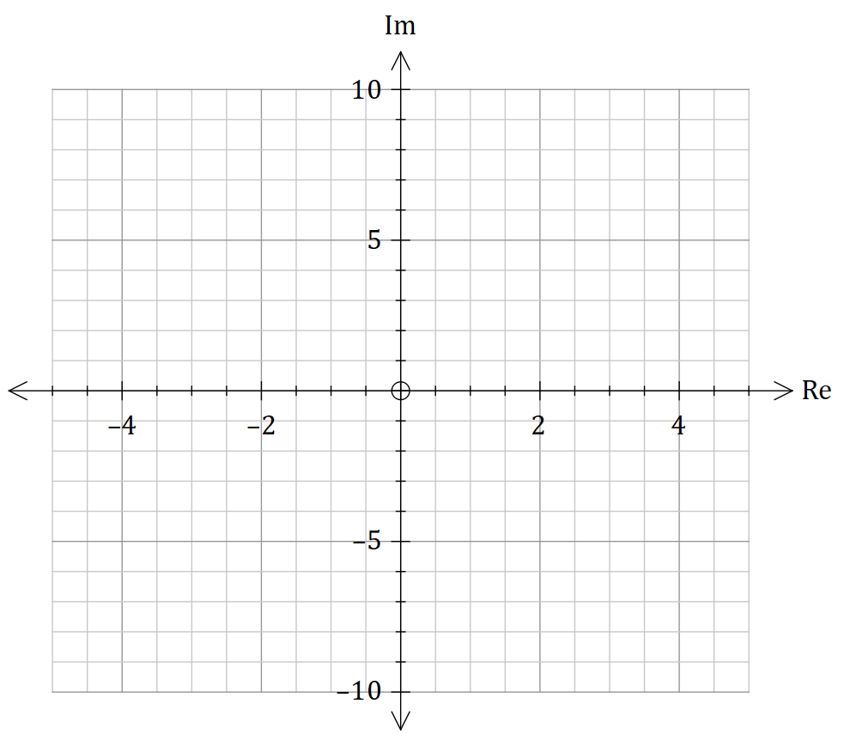Sketch the following loci.

1. (3 marks)



(2 marks)

1. (5 marks)



**Question 20 (14 marks)**

The complex numbers is the vector addition of and (). The complex numbers

and are listed below.

and

1. Sketch the locus of in the Argand diagram below. (5 marks)

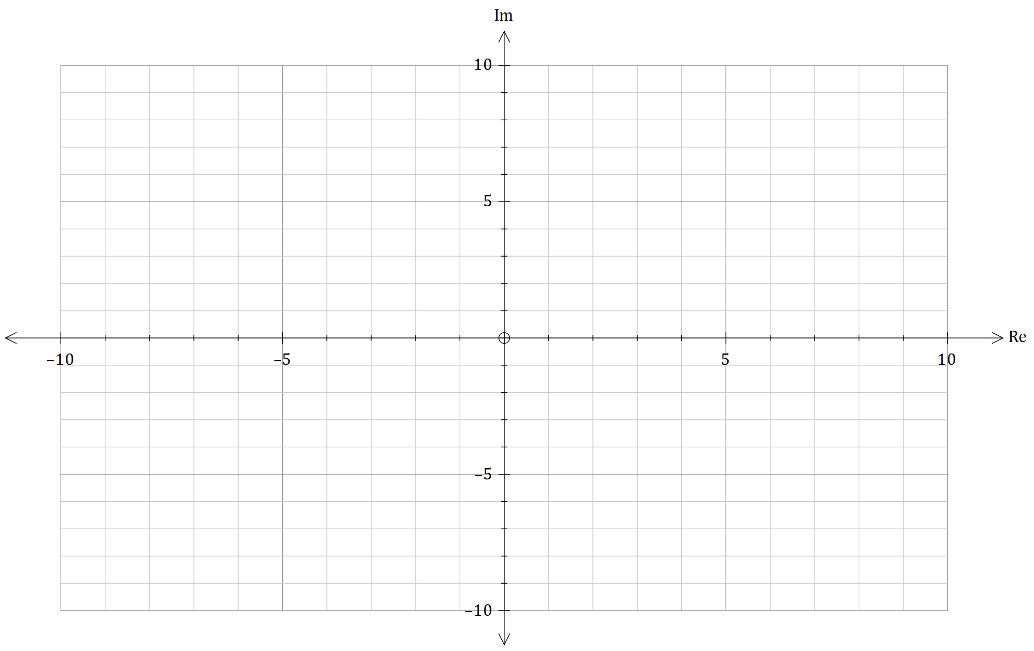

The complex number lies on the locus of such that the argument of takes its maximum

value.

1. Hence, by finding the exact value of , show clearly that the maximum argument of is given in the expression. (5 marks)
2. Find in the form of , where and are exact values. (4 marks)

**Question 21 (13 marks)**

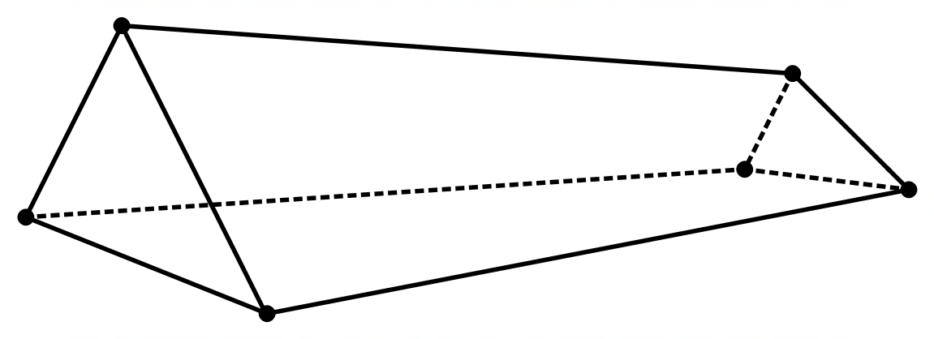

The figure above shows an irregular hollow shape, consisting of two non-congruent, non-parallel

triangular faces and , and two non-congruent quadrilateral faces and .

The equations of the straight lines and are shown, where and are parameters.

Further on, the plane face has the vector equation and the point labelled

as has the position vector . It is noted that the acute angle between the plane face

and the straight line is labelled as (The symbol is pronounced as ‘Chi’)

Hence, prove with justification and reasoning, that the acute angle between and , is.

**END OF CALCLUATOR-ASSUMED**

Supplementary page

Question number: _________

Supplementary page

Question number: _________

)

Supplementary page

Question number: _________

Supplementary page

Question number: _________

Supplementary page

Question number: _________

Supplementary page

Question number: _________